**Evidence for Project Unit**

Name: Heather Rae

Cohort: 15

Date here: 2017

**P- 1 Github Contributors page**

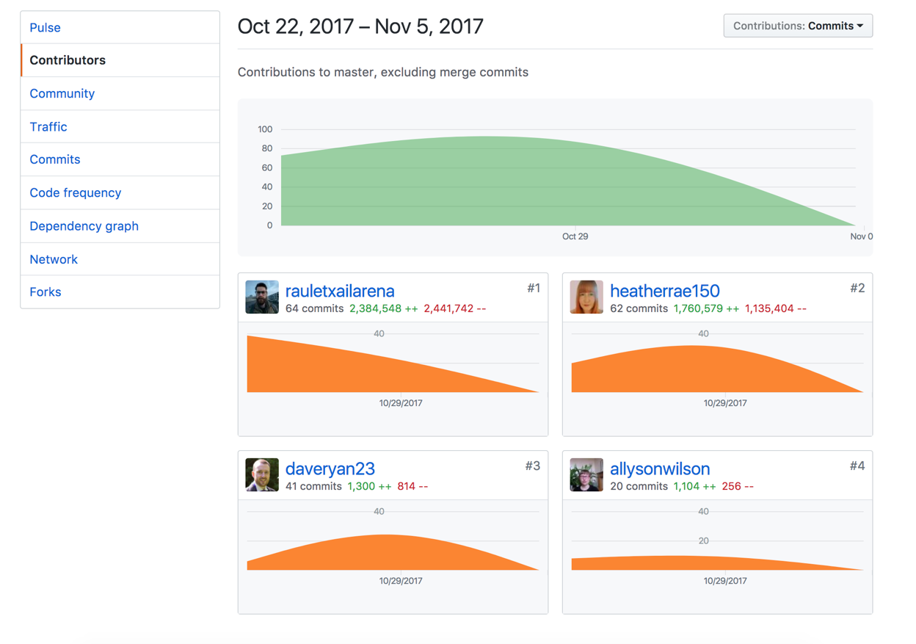

**P- 2 Project Brief**

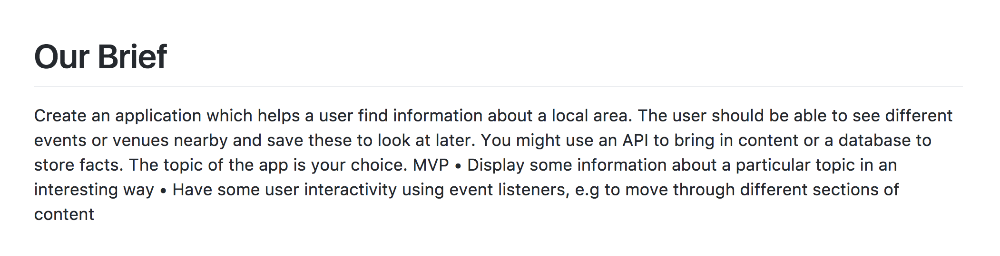

**P-3 Use of Trello**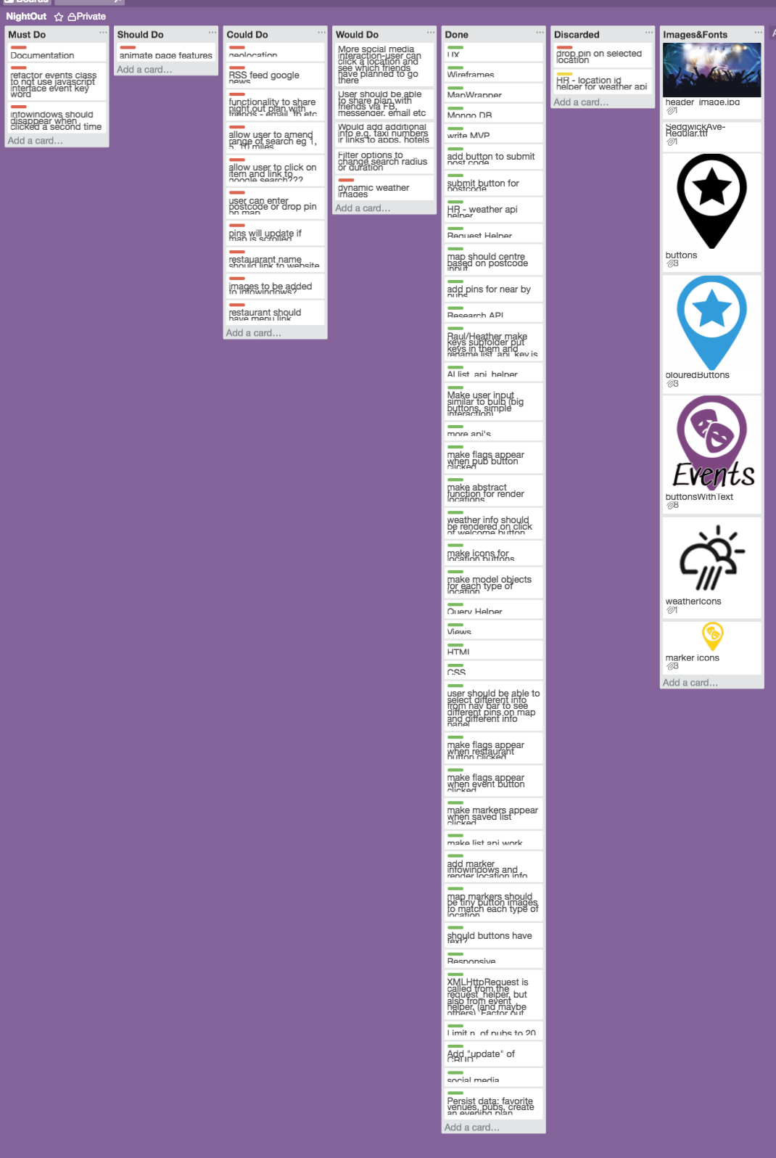

**P-4 Acceptance Criteria**

|  |  |  |
| --- | --- | --- |
| **Acceptance Criteria** | **Expected Result/Output** | **Pass/Fail** |
| User can enter a postcode and view information about the local area | After entering a postcode, user will see a map with markers pointing to pubs, restaurants and events | Pass |
| User can enter city name to retrieve information | After entering a city name, user will see a map with markers pointing to pubs, restaurants and events | Fail |
| User can view weather conditions for local area | After entering postcode, user can view weather conditions for local area | Pass |
| User can select marker to view further information | After clicking a marker, infowindow is visible showing further information about the location | Pass |
| User can save locations to a saved list | Details of location are persisted in the database and can be viewed later | Pass |
| User can share saved items with friends through social media | User should be able to click on saved plan and send details to friends | Fail |

**P-5 User sitemap**

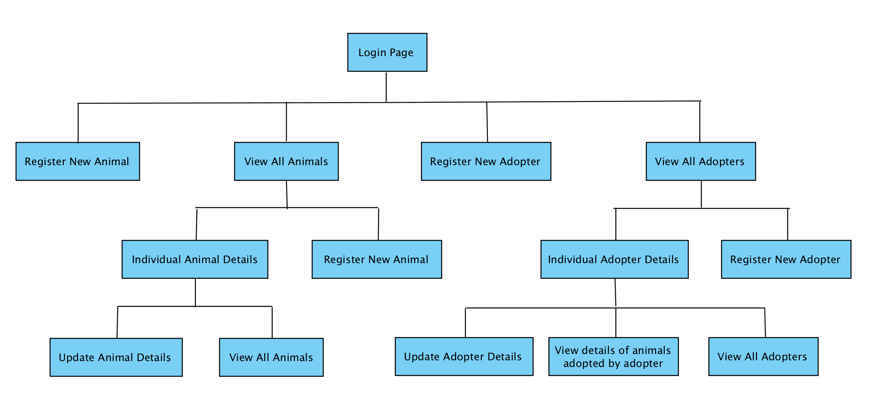

**P-6 Wireframes designs**

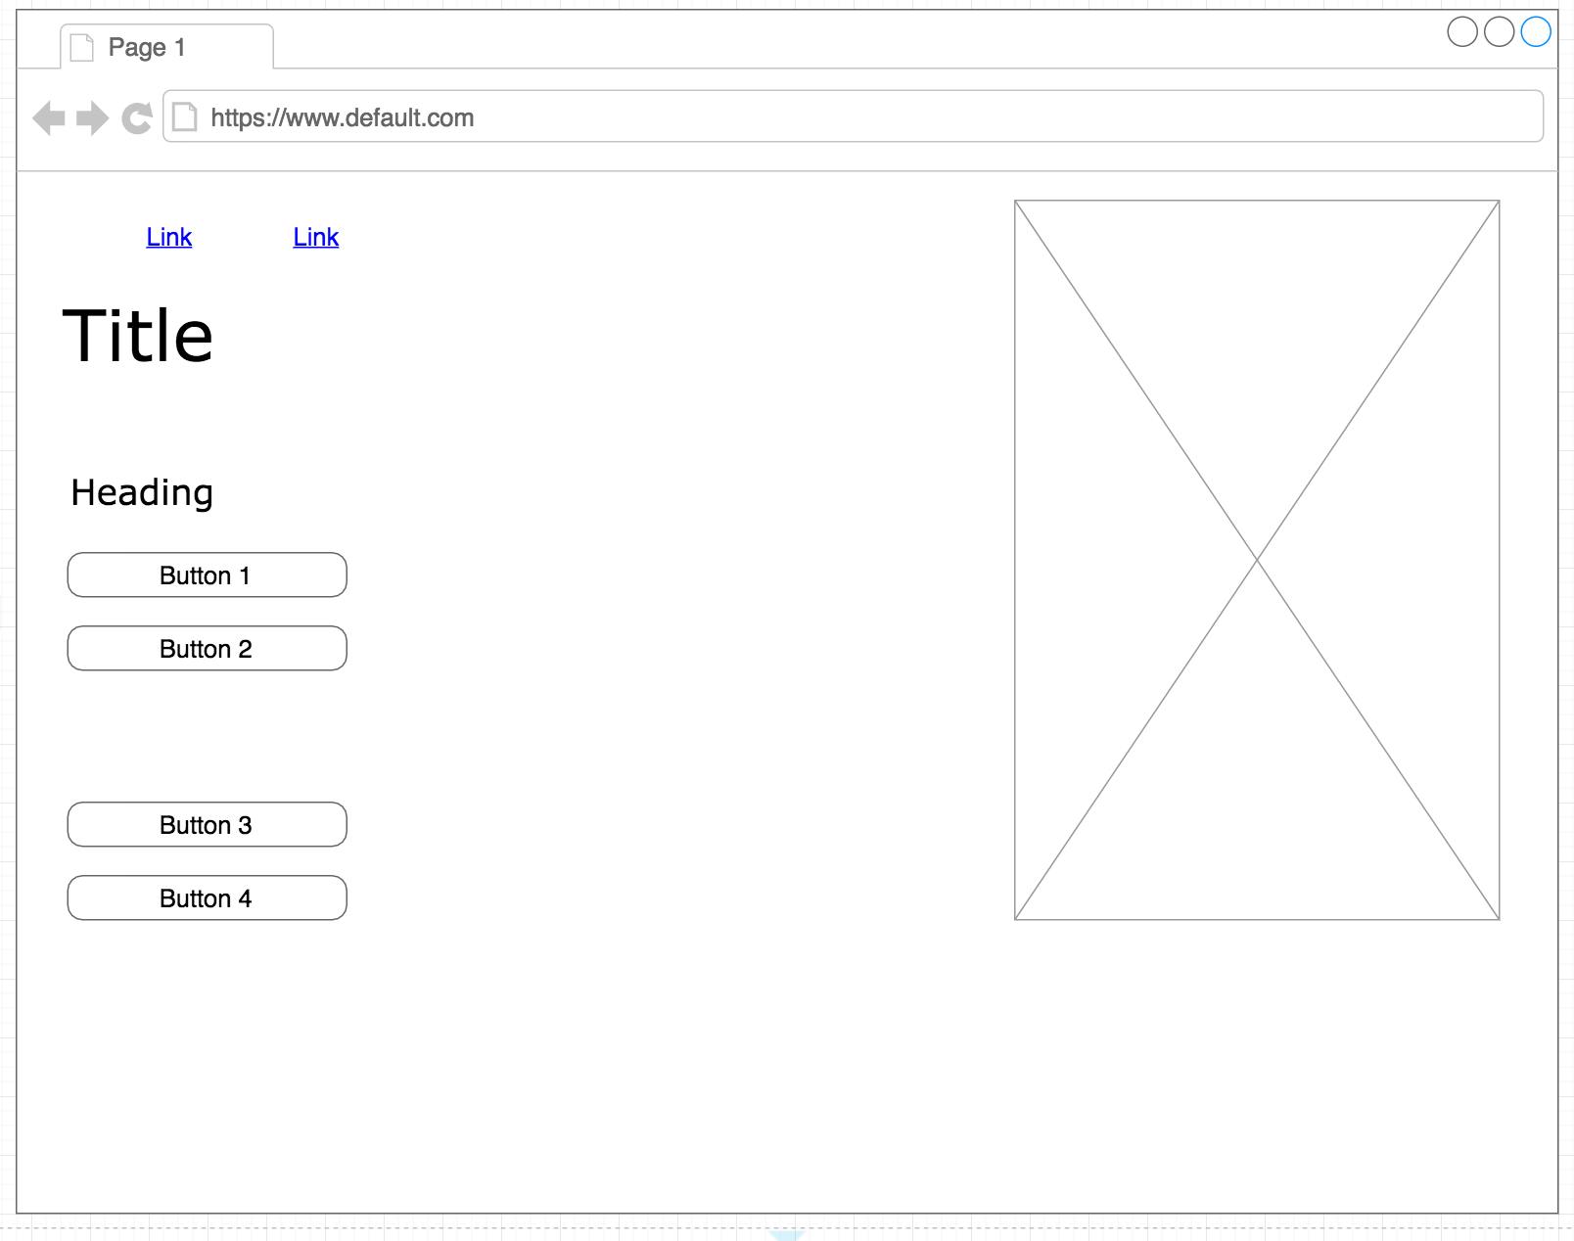

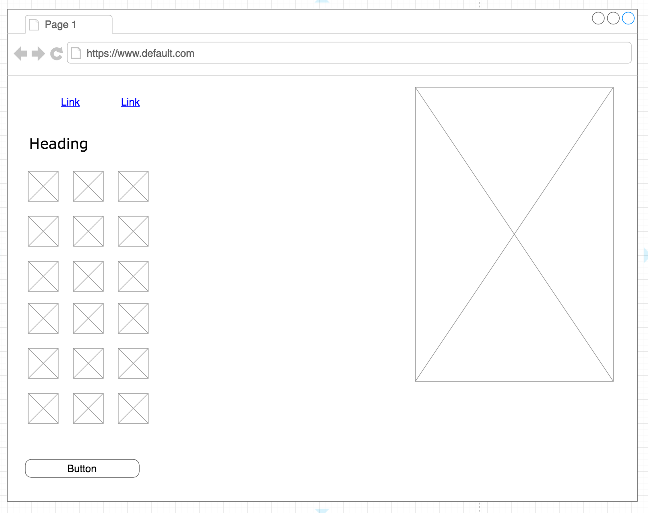

**P-7 System interactions diagrams**

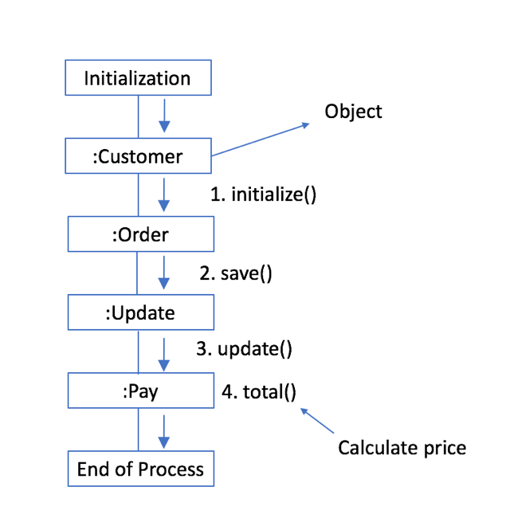 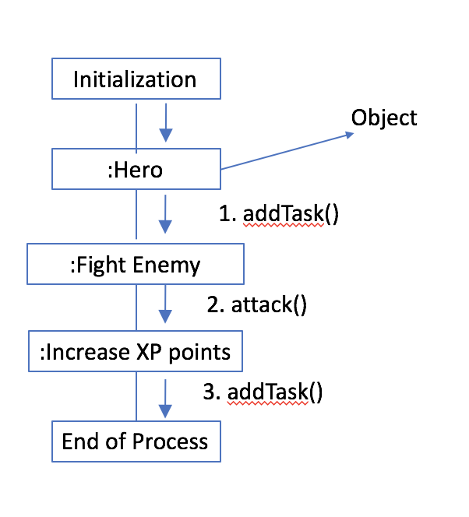

**P-8 Two Object Diagrams**

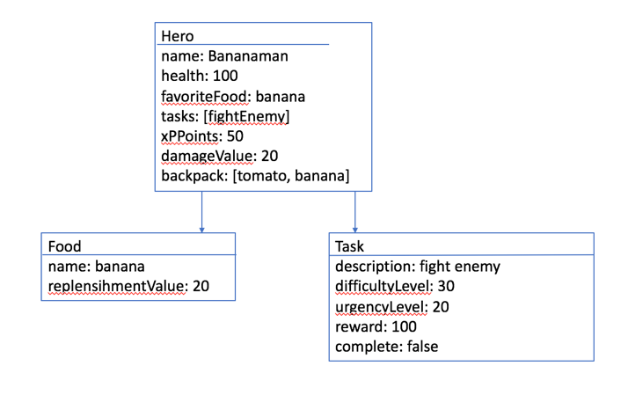 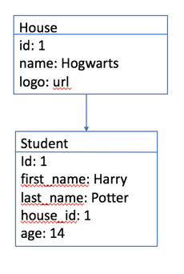

**P- 9 D.T.- a Choice of two algorithms (find the algorithms on a program you might have written, show the code you have used. )**

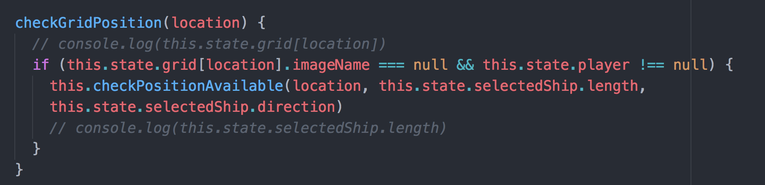

This algorithm checks a user has selected a player number and has chosen an empty square to place their battleship.

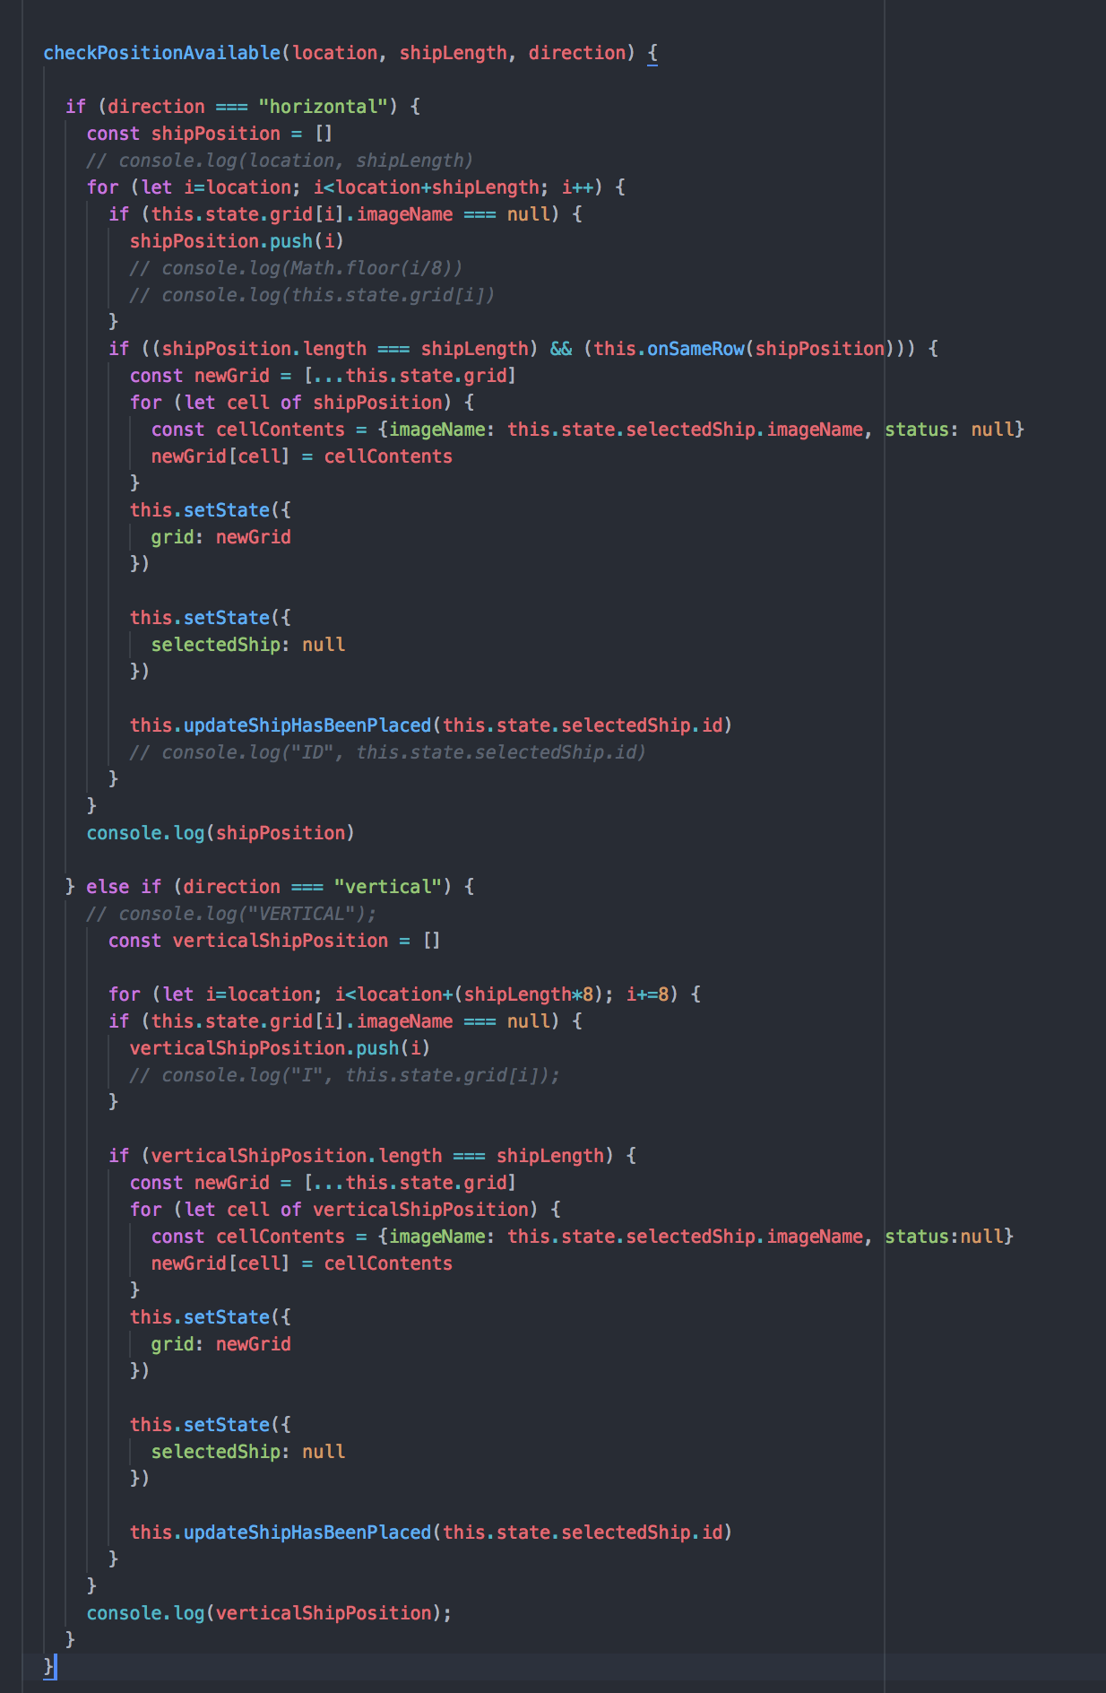

This algorithm checks required space for battleships valid and has no other ships on it already. If conditions are met then the algorithm changes the status of the squares to have a ship on them.

**P - 10 Example of Pseudocode**

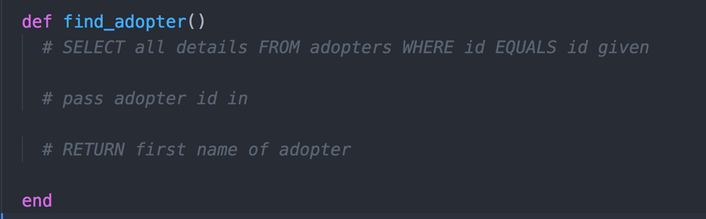

**P - 11 Take a screenshot of one of your projects where you have worked alone and attach the Github link.**

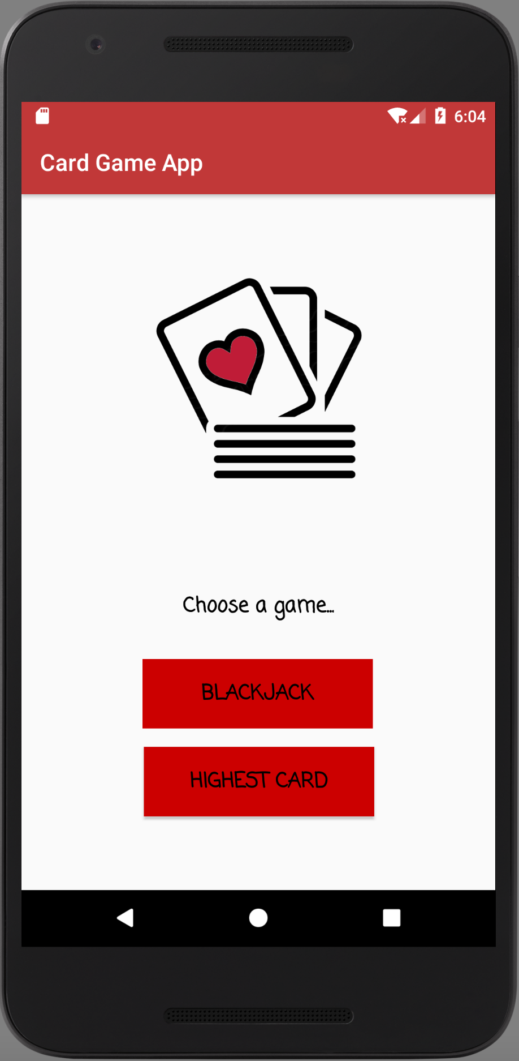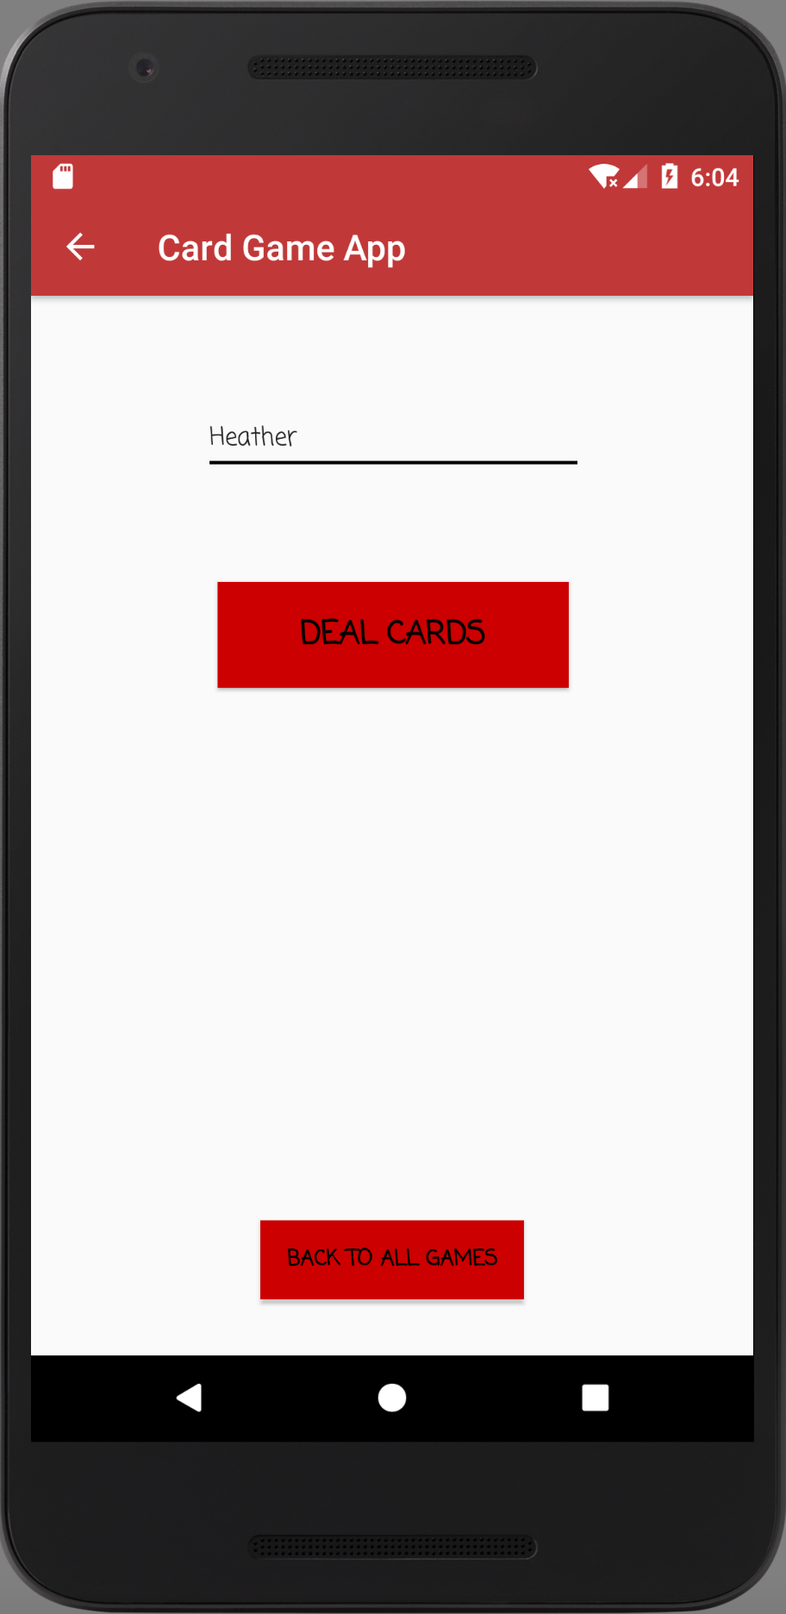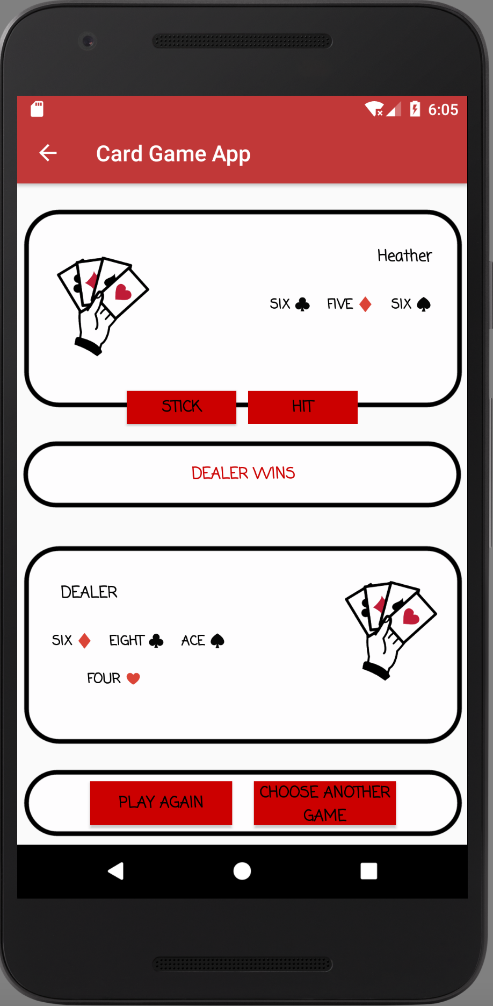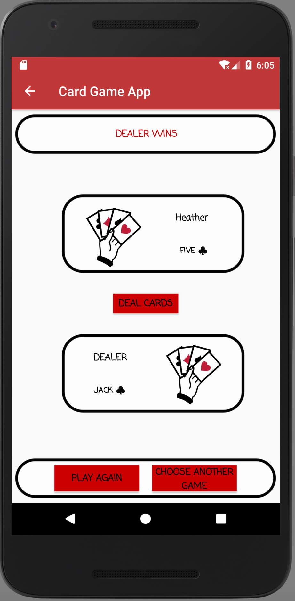

**https://github.com/heatherrae150/Java-BlackJack**

**P - 12 Screenshot of your planning and the different stages of development to show changes.**

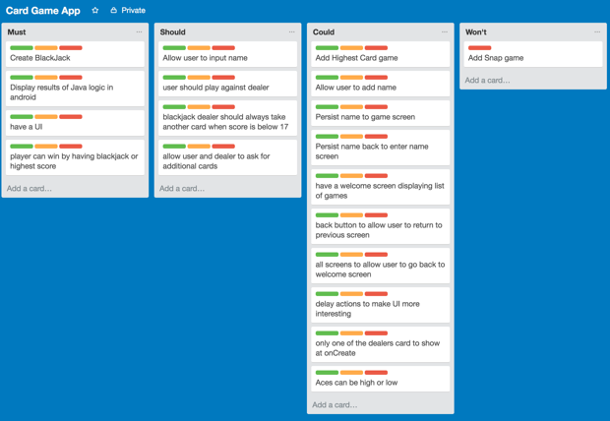

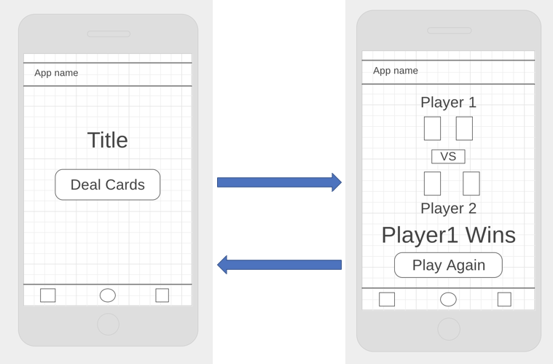

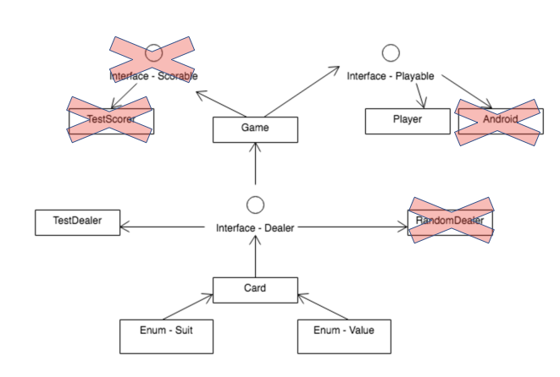

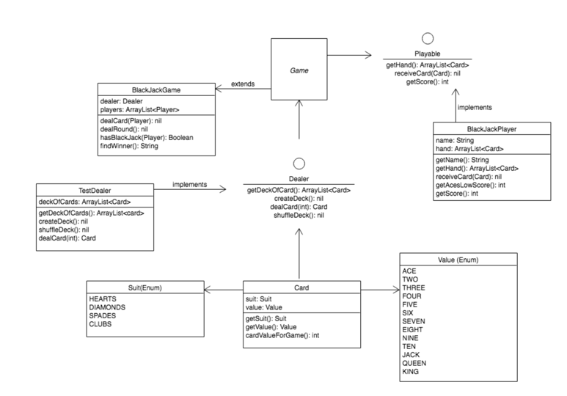

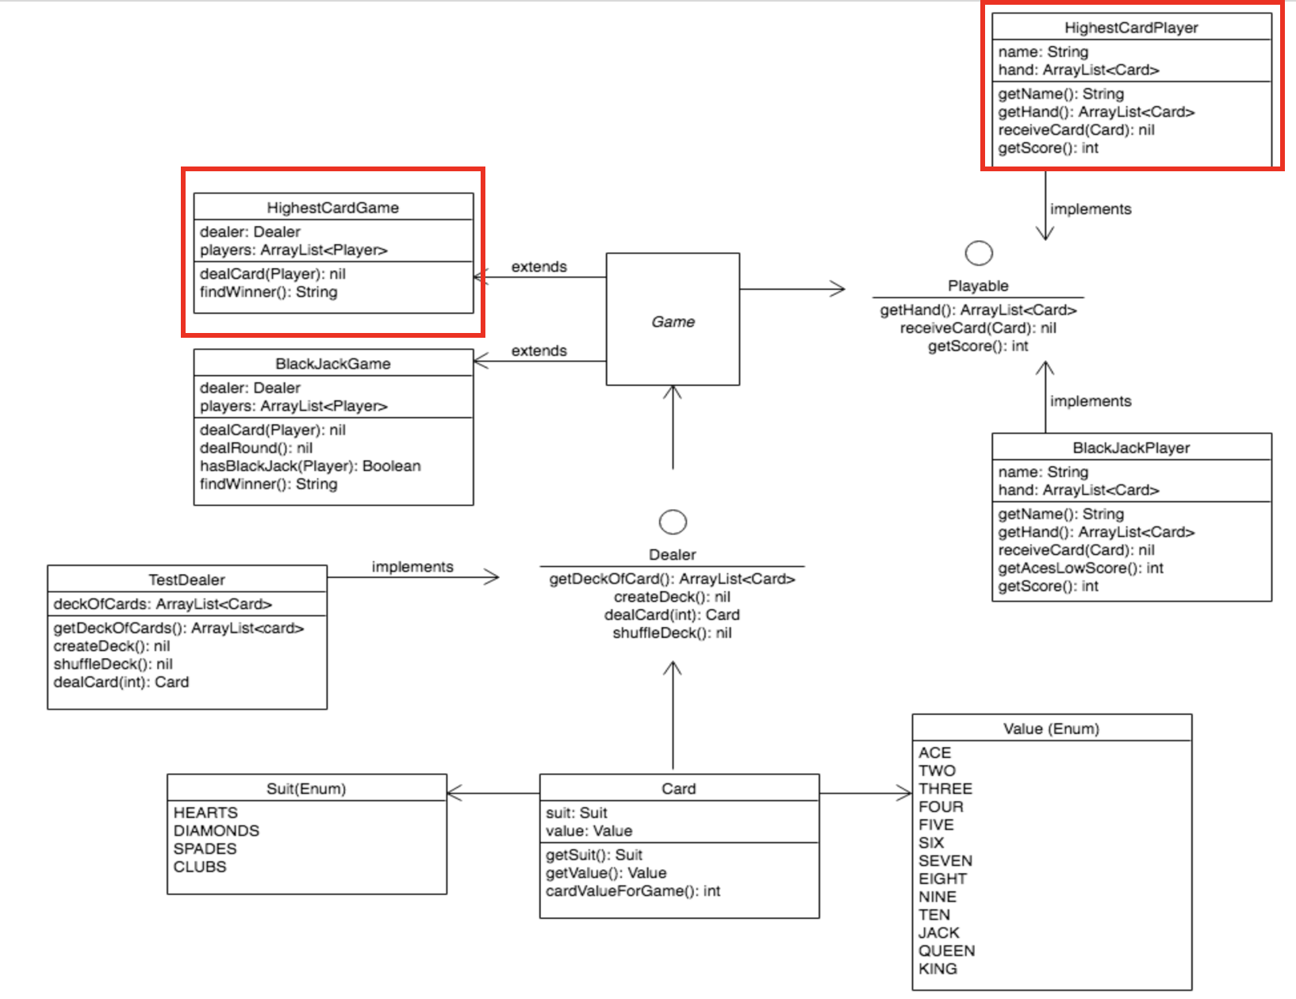

**P - 13 User input**

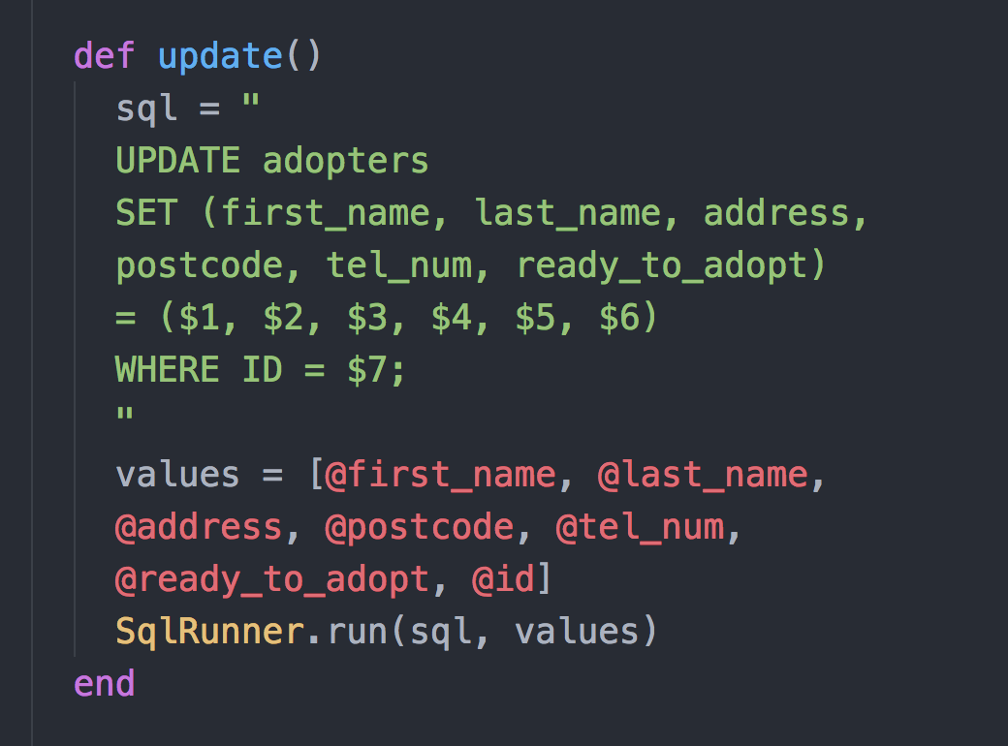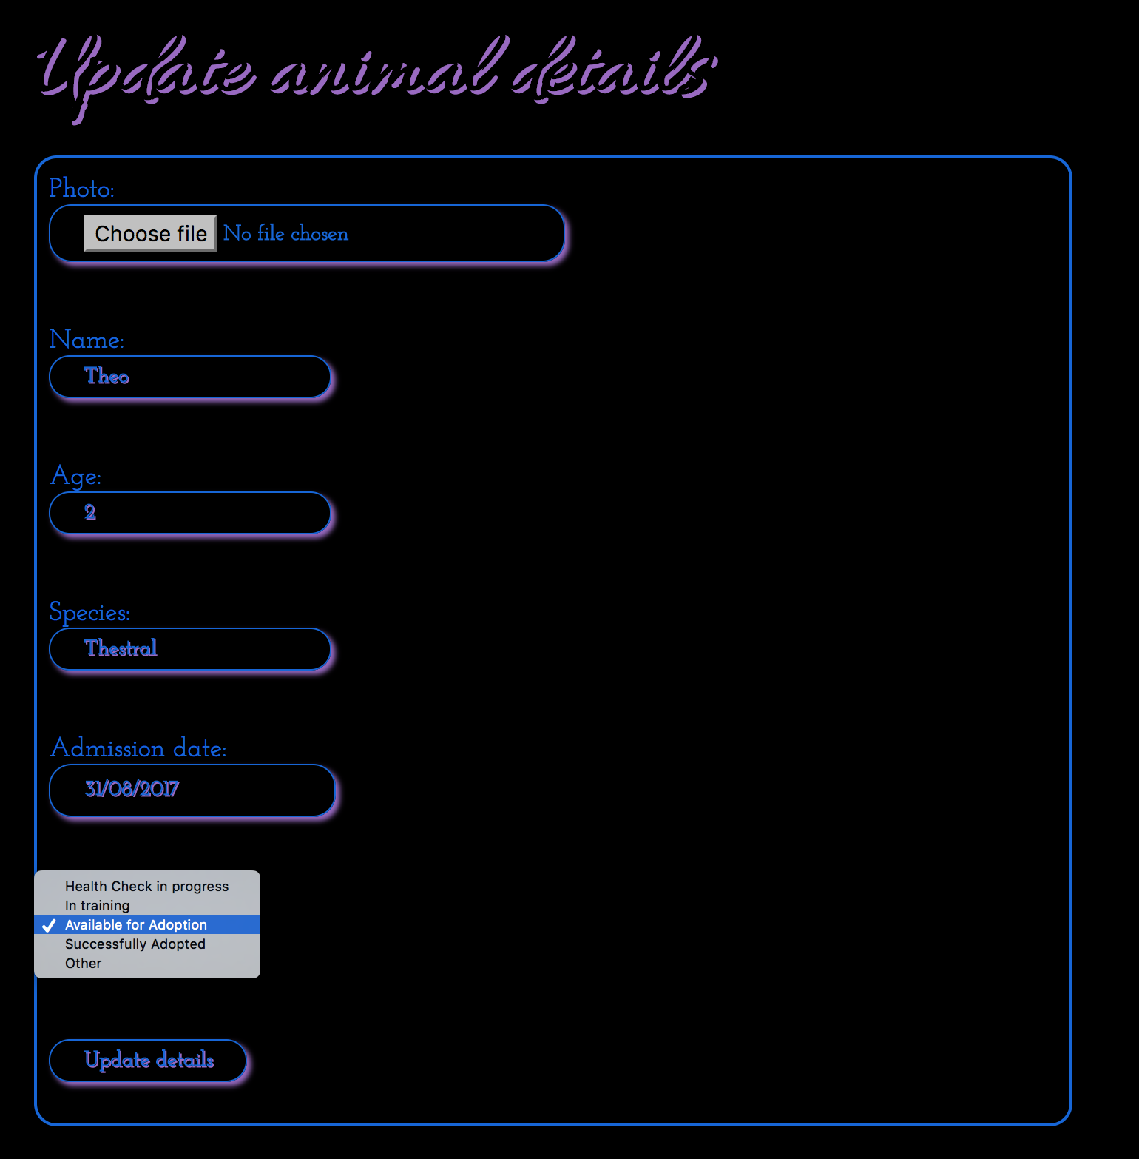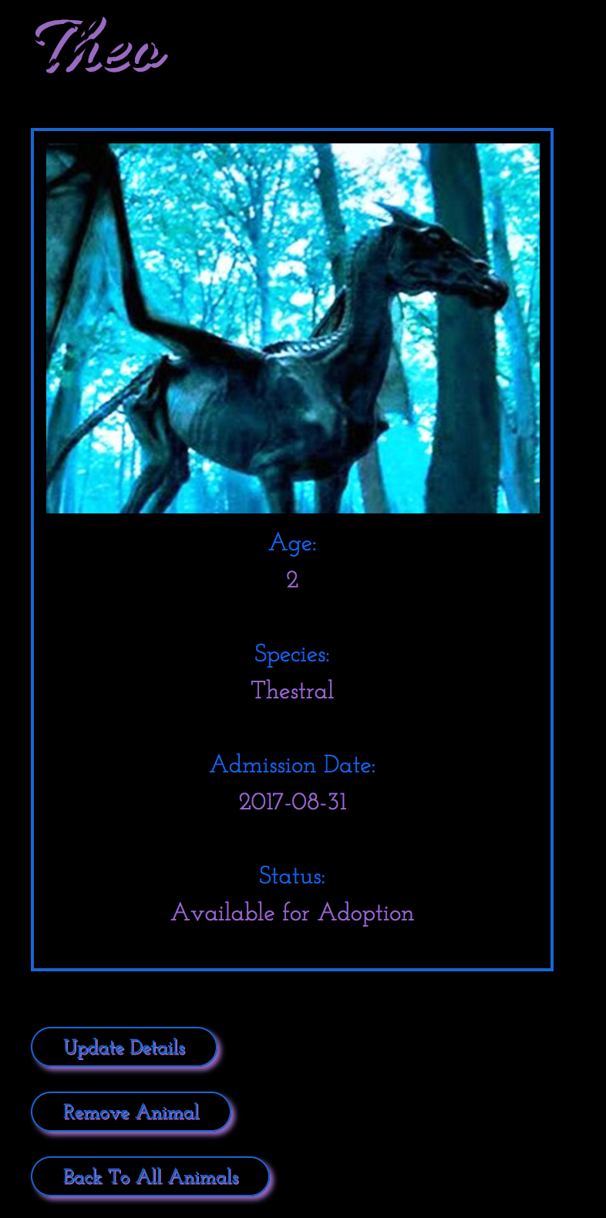

**P - 14 Interaction with data persistence**

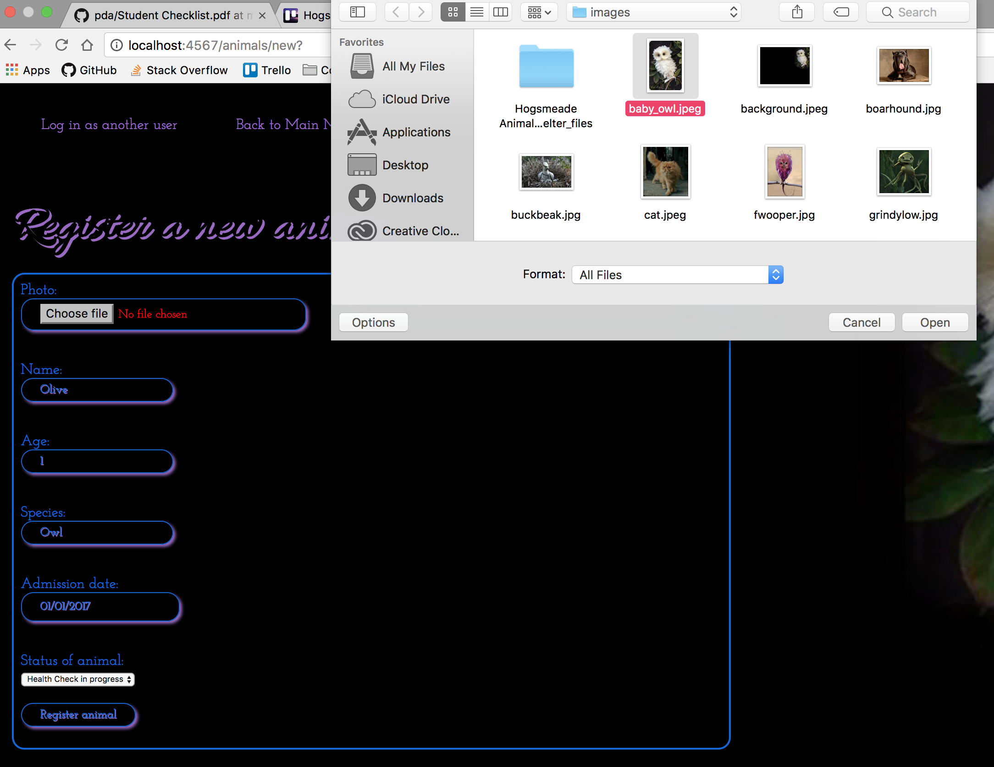

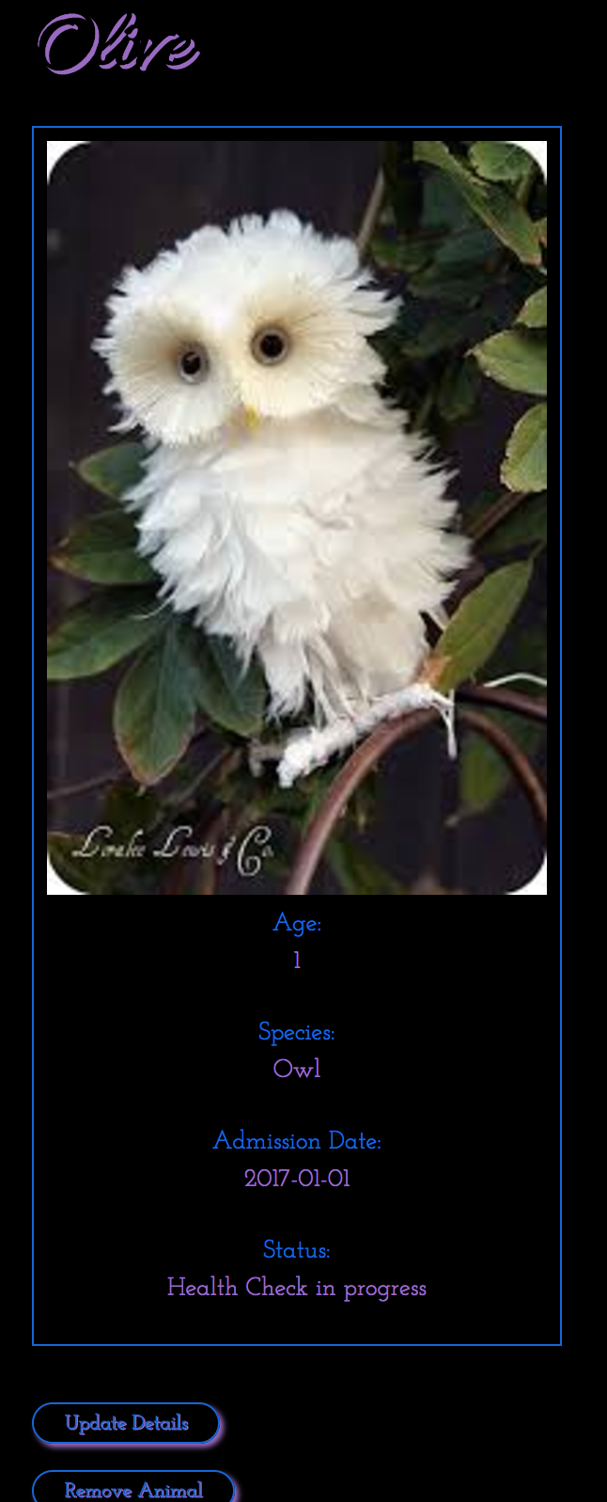

**P - 15 User output result**

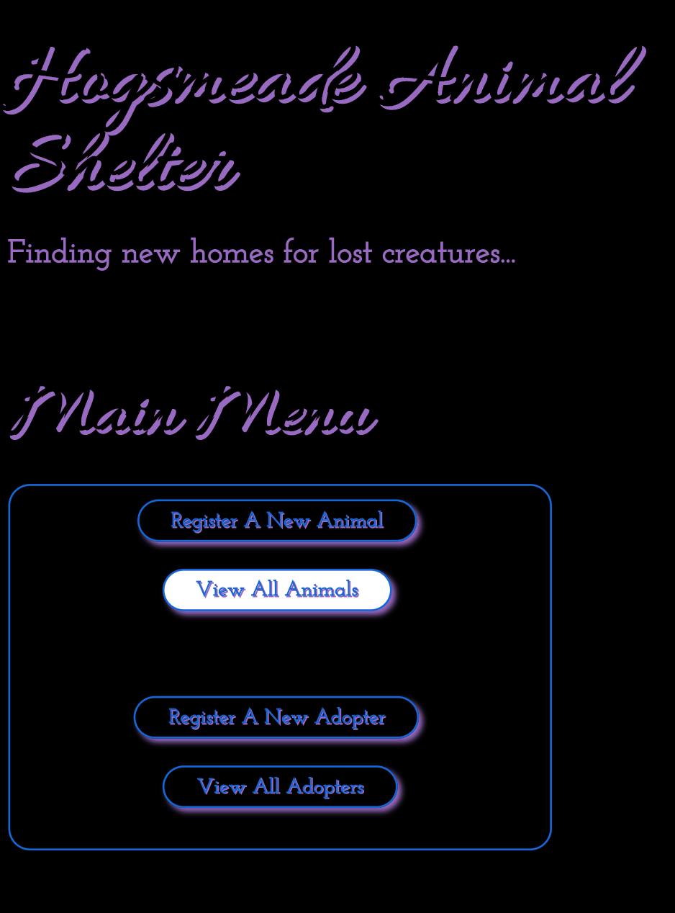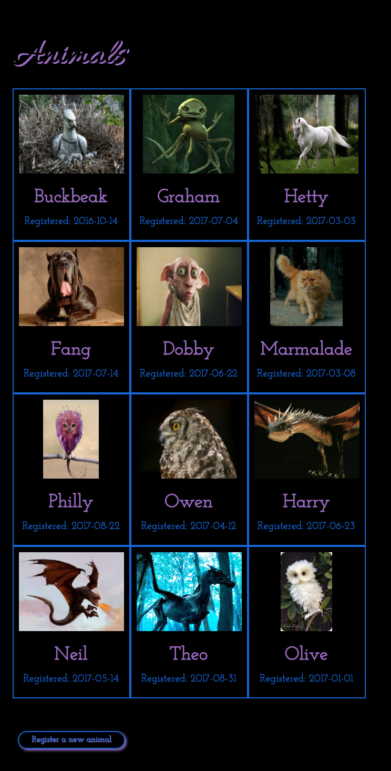

**P - 16 Show an API being used within your program.**

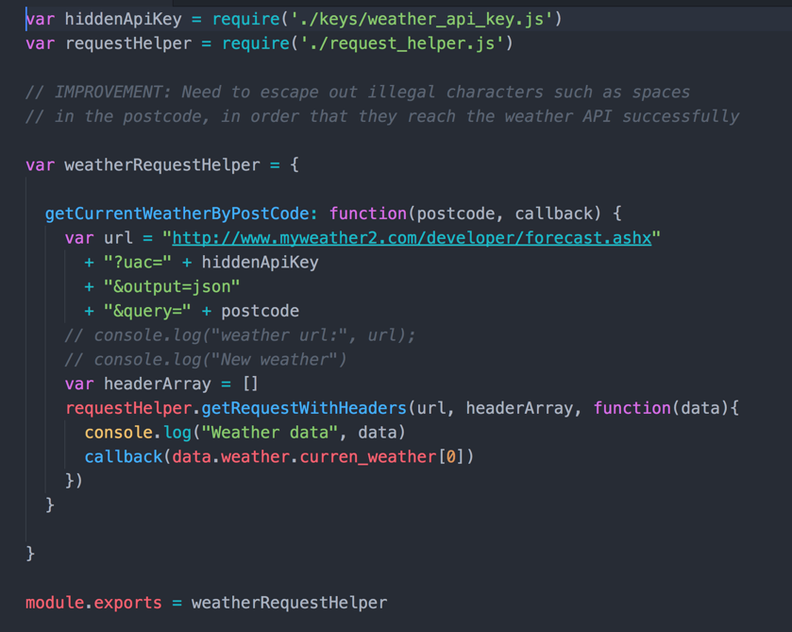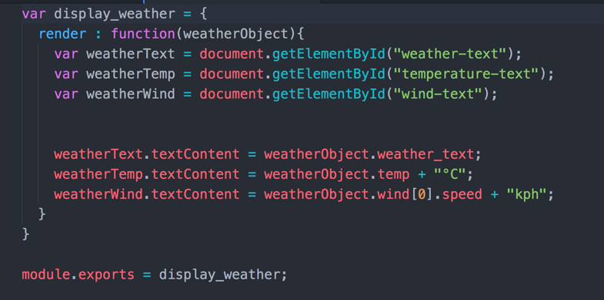

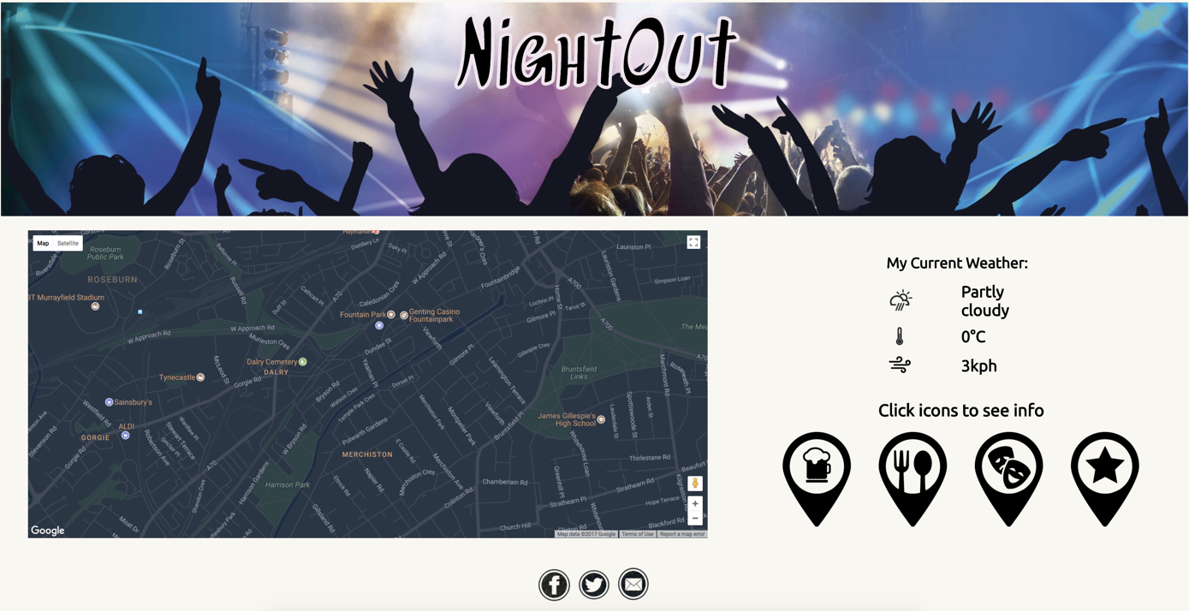

**P -17 Produce a bug tracking report**

|  |  |  |  |
| --- | --- | --- | --- |
| **User should be able to place a ship** | **Fail** | **Click event now allows user to select which ship to place which provides the number of sqaures required for the ship** | **Pass** |
| **User should be able to place a ship horizontally or vertically** | **Fail** | **Left click event used for horizontal placement and right click implemented for vertical placement** | **Pass** |
| **Ship should not be allowed to run over onto next row** | **Fail** | **Used modulus to check all required squares are on same row. If condition not met, ship cannot be placed** | **Pass** |
| **User must be able to place make a guess** | **Fail** | **Used click event to collect index of square clicked on** | **Pass** |
| **When guessing, user should be able to see if guess was a hit or miss** | **Fail** | **Used socket to render real time hit or miss information** | **Pass** |

**P - 18 Demonstrate testing in your program.**

**Test failing**

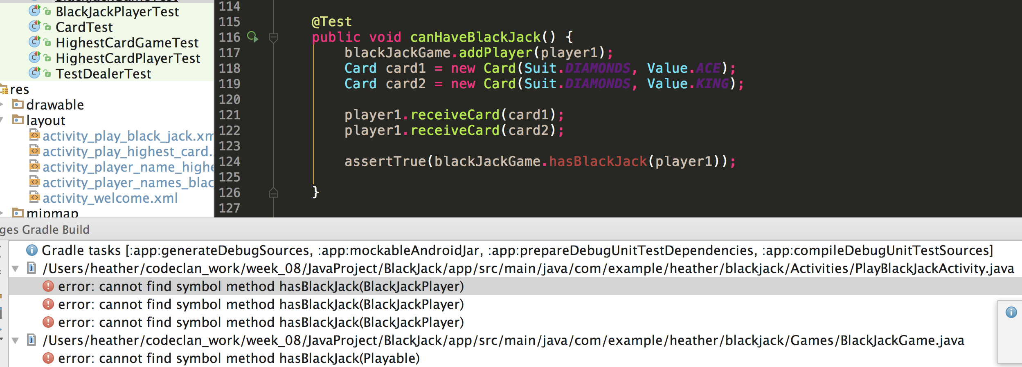

**Test passing**

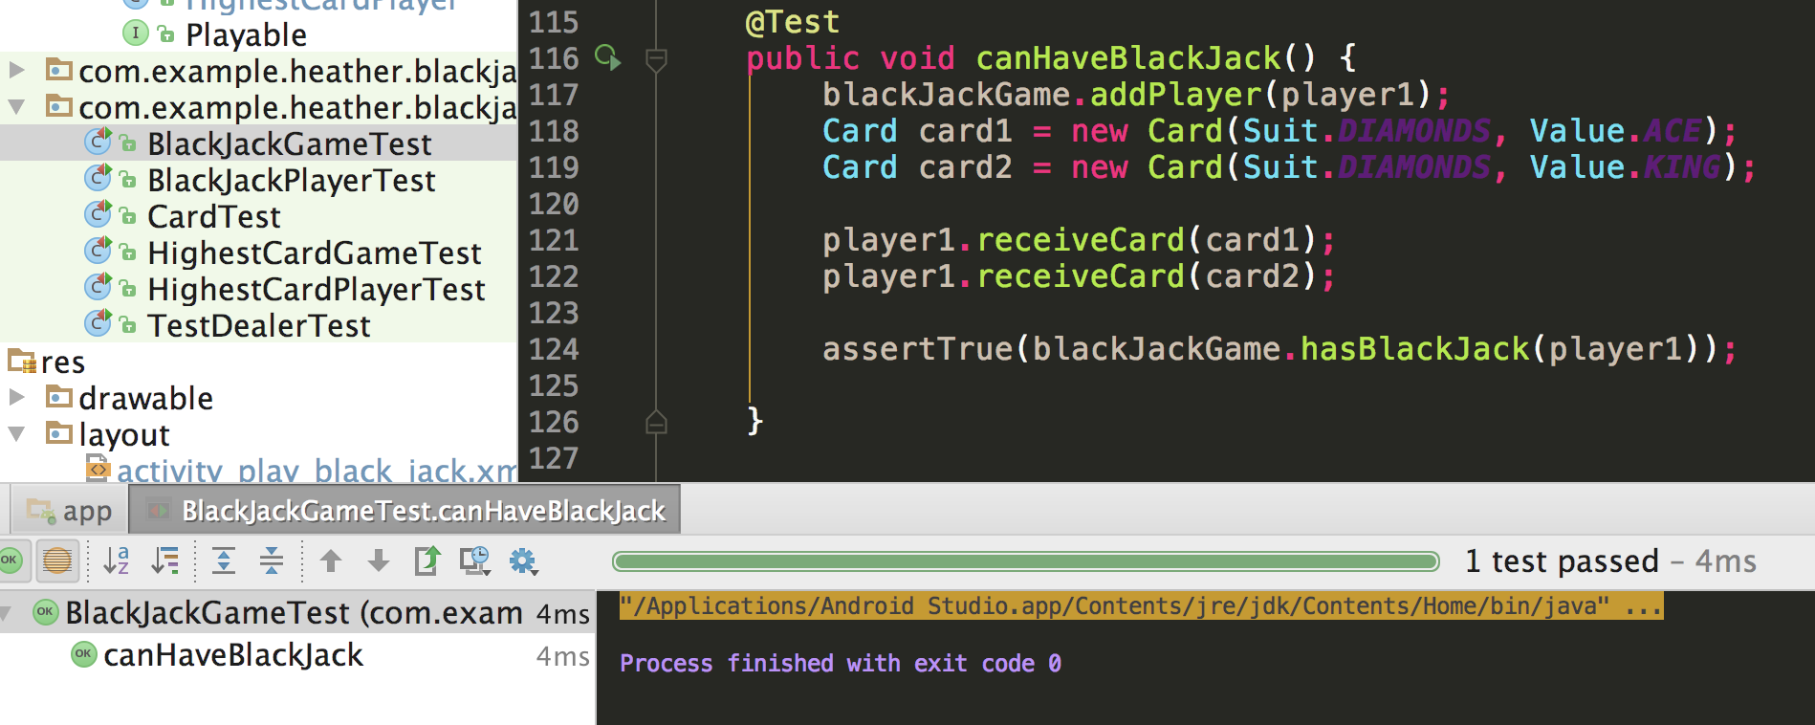

**Test failing**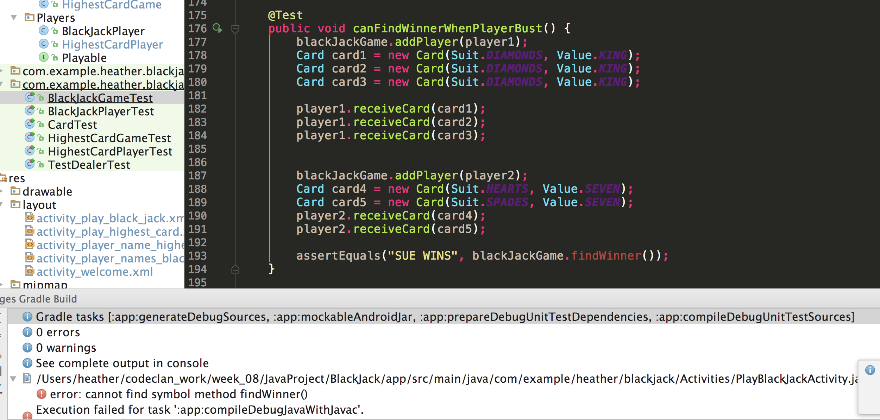

**Test passing**

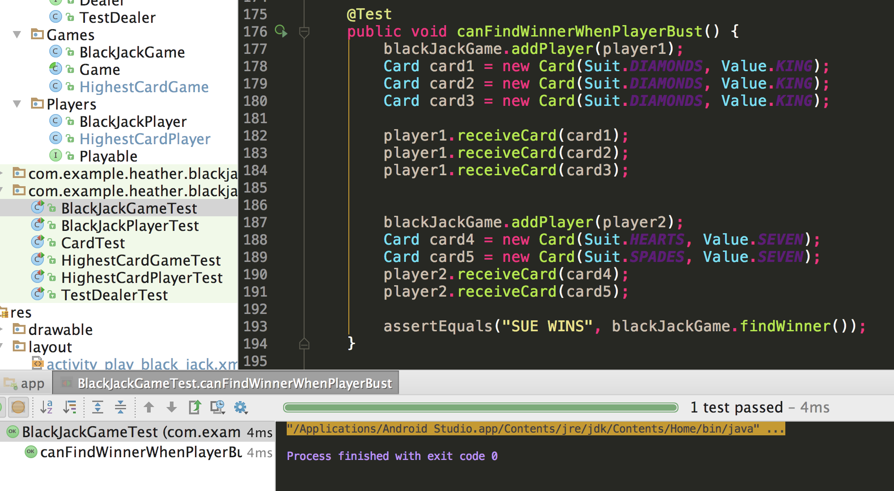

**Test failing**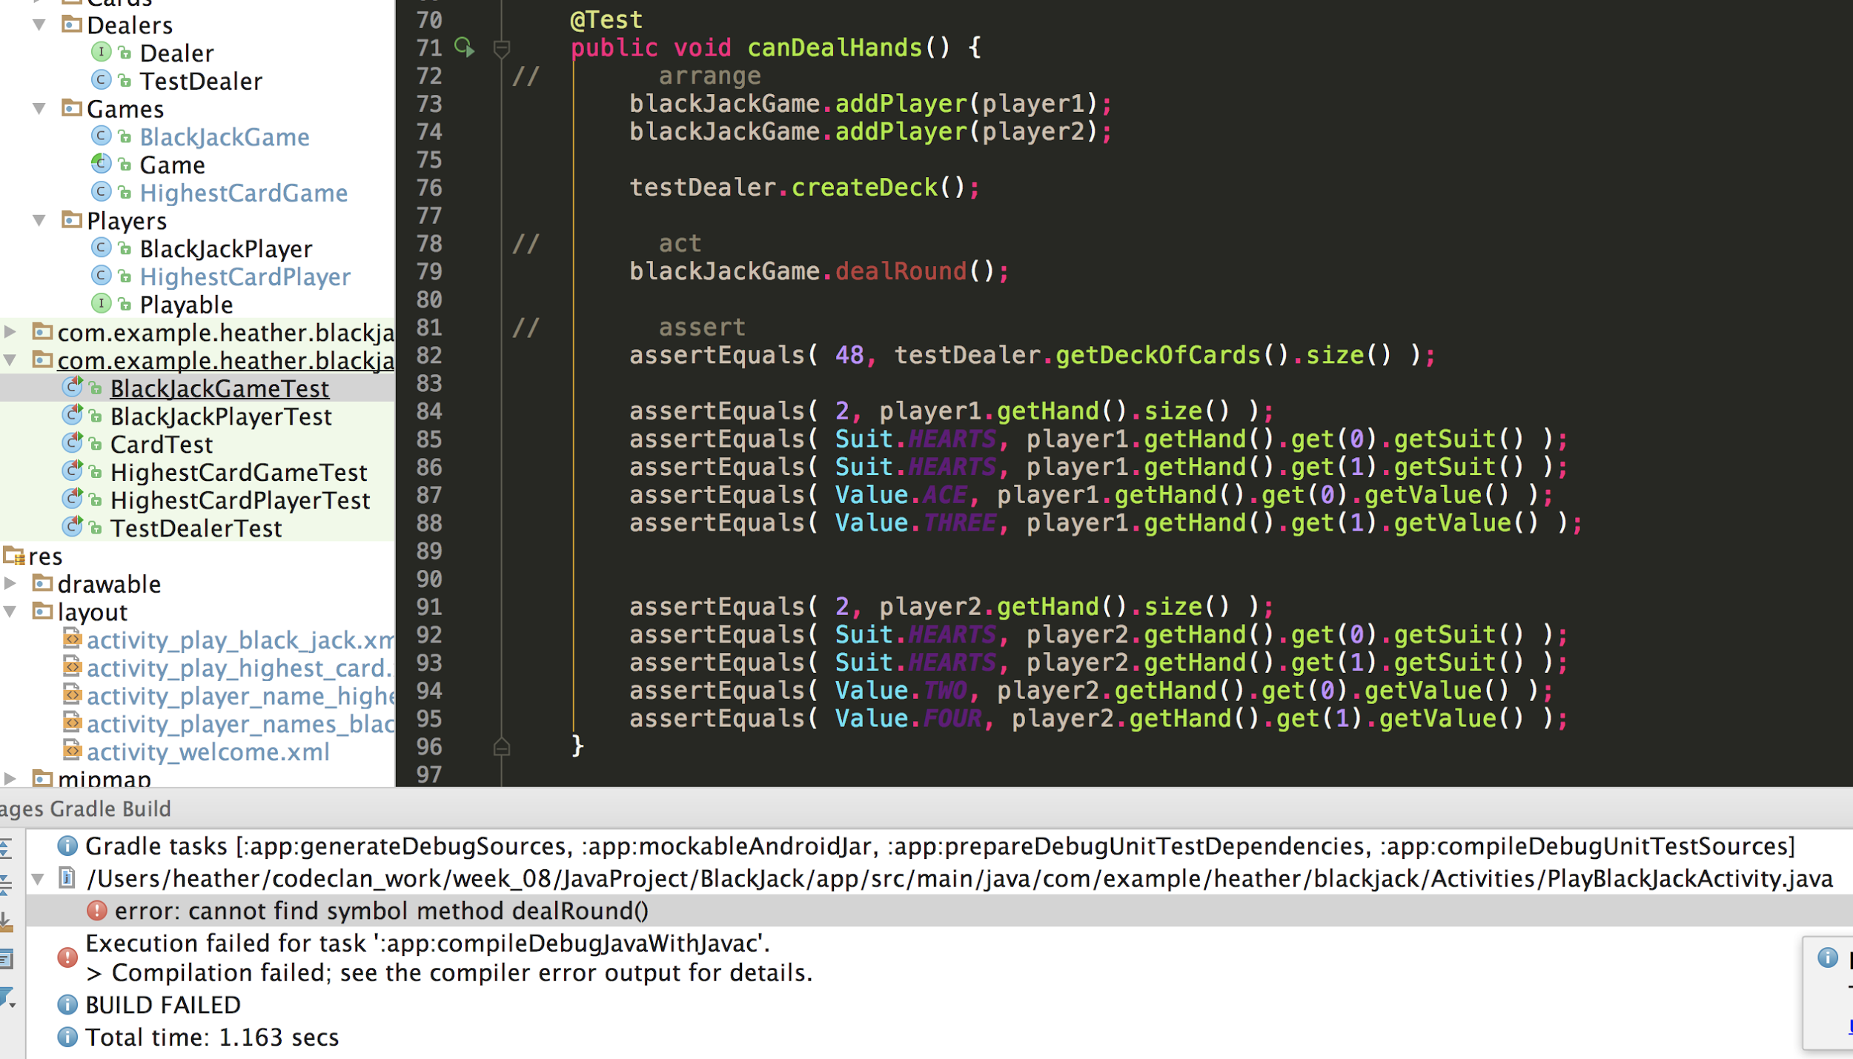

**Test passing**

